FORMATTING THE WORKS CITED PAGE (MLA FORMAT)
Whenever you incorporate outside sources into your own writing, you must provide both in-text citations (within the body of the paper) and full citations (in the works cited page). The in-text citations point your reader toward the full citations in the works cited page.
That's why the first bit of information in your in-text citation (generally, the author's name; if no name is provided, the title of the article/book/webpage) should directly match up with the beginning of your works cited entry for that source. For further information about in-text citations, please read "Formatting In-Text Citations."
For example, let's say I have a quote from Benedict Anderson's Imagined Communities in my research paper. Within the body of the paper, following the quote, I include the following in-text citation: (Anderson 56). This information points to the book's entry in my works cited page:
Anderson, Benedict. Imagined Communities: Reflections on the Origin and Spread of Nationalism. London: Verso, 2006. Print.
When your reader sees the in-text citation in your essay, she may decide that the source might be valuable for her own research. When she looks at the works cited page, she can easily locate the source (because the works cited page is alphabetized and because she has the in-text citation as her referent) and then can use the full citation to retrieve a copy of the source for her own research. But aside from providing the reader with resources for her own research, the works cited page serves another function: it establishes the writer's credibility. If a writer fails to include in-text citations and/or a works cited page, that writer has plagiarized because he or she has neglected to provide the publication information of the source. In addition, when a reader locates undocumented information in an essay, she will likely think that the information was made up by the writer or that the information was stolen from a source, or plagiarized. And when a reader peruses a writer's works cited page, she can see the types of sources used by the writer, assessing those sources in terms of their credibility. For instance, if a reader reads my works cited page and sees I cite sources from university presses such as Oxford UP and Cambridge UP, she will know that I've incorporated credible sources into my research paper. Thus, including both in-text citations and a works cited page in a research paper provides the writer with ethos, or credibility.
Now let's take a look at how to properly format a works cited page according to MLA guidelines:
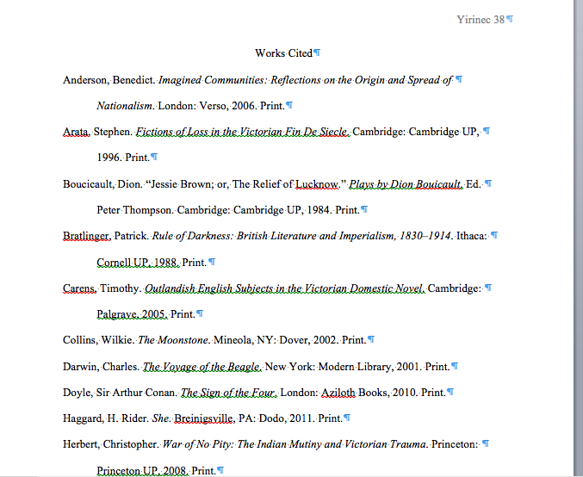

Placement
According to MLA style guidelines, the works cited page should appear after the body of your paper and any accompanying endnotes. It should begin on a new page, and the pagination should continue from the body of the paper. In the above example, the works cited page begins on page 38, which means that the essay concluded on page 37.

General format
The works cited page should be double-spaced throughout. The first line of each entry should be flush with the left margin; if the entry extends more than one line, ensuing lines should be indented 1/2 inch from the left margin. The first page of the works cited list should have the title "Works Cited," not "Bibliography." The works cited title should appear in the same manner as the paper's title: capitalized and centered—not bolded, within quotation marks, italicized, underlined, or in a larger font.

Entries
The entries should be alphabetized based on the author's last name. According to MLA guidelines, author names come first in an entry, then titles, then the publication information (city of publication, publisher, and date of publication), and then the type of media—the details for different types of sources vary, but this is the general structure followed. Note that if the city is not "well-known" and there is more than one city with that name, unlike New York and London, then the state or territory should be included after the city, e.g., "Roswell, GA: 2006." If no name is provided for a given source, the title of the work/webpage will take the place of the author's last name and should still be placed in its proper alphabetical location. Also note that "university" and "press" are always abbreviated "U" and "P" in works cited entries.
Here are some guidelines for commonly used sources:

Single-Authored Book
Last Name, First Name. Title of Book. Place of Publication: Publisher, Date of Publication. Type of media.
Example:
Bratlinger, Patrick. Rule of Darkness: British Literature and Imperialism, 1830–1914. Ithaca: Cornell UP,
1988. Print.

Book with Multiple Authors
Last Name, First Name (of first author listed), and First Name Last Name (of second author, etc.). Title
of Book. Place of Publication: Publisher, Date of Publication. Type of media.
Example:
Sabherhagen, Fred, and James V. Hart. Bram Stoker's Dracula: A Francis Ford Coppola Film. New York:
Signet, 1992. Print.

Article or Chapter in an Edited Collection (or Textbook)
Last Name, First Name. "Article Title." Title of Book. Ed. First Name Last Name (of Editor). Place of
Publication: Publisher, Date of Publication. Page Range of Article. Type of Media.
Example:
Vieregge, Quentin. "Writing as Process." Negotiating Writing Spaces. Ed. Jennifer Yirinec and Lauren
Cutlip. Plymouth, MI: Hayden-McNeil, 2011. 57–59. Print.

Article in a Print Journal
Last Name, First Name. "Article Title." Title of Journal. Volume #.Issue # (Date of publication): Page Range
of Article. Print.
Example:
Rogers, Pat. "Crusoe's Home." Essays in Criticism 24.4 (Oct. 1974): 375–90. Print.

Journal Article Accessed Using an Electronic Database
Last Name, First Name. "Article Title." Journal Name Volume #.Issue # (Date of publication): Page Range
of Article. Database. Web. Date of Access.
Example:
Lamont, Rose C. "Coma versus Comma: John Donne's Holy Sonnets in Edson's WIT." The Massachusetts
Review 40.4 (Winter 1999–2000): 569–75. JSTOR. Web. 30 April 2012.

Article Accessed from an Online Journal
Last Name, First Name. "Article Title." Journal Name Volume #.Issue # (Date of publication): n.pag. Web.
Date of Access.
Example:
Haynsworth, Leslie. "All the Detective's Men: Binary Coding of Masculine Identity in the Sherlock Holmes
Stories." Victorians Institute Journal 38 (2010): n.pag. Web. 16 May 2012.

Article from a Webpage
Last Name, First Name (if given). "Title of Webpage." Website Title. Publisher of website (often found at the bottom
of the page), date of last update. Web. Date of Access. See (URL is only necessary if you think your
reader won't easily be able to locate the webpage).
Example:
"Opening Night: Wit Starring Cynthia Nixon." Broadway.com. Broadway.com, Inc., 2012. Web. 12 Feb. 2012.

Entire Website
Website Title. Publisher of website, date of last update. Date of Access. See (URL is only necessary if you
think your reader won't easily be able to locate the webpage).
Example:
Broadway.com. Broadway.com, Inc., 2012. Web. 12 Feb. 2012.
For information about how to format the works cited entries for different sources, consult The MLA Handbook for Writers of Research Papers (7th edition). Or, consult the Purdue OWL: http://owl.english.purdue.edu/owl/resource/747/06/.

"Formatting the Works Cited Page (MLA)" was written by Jennifer Yirinec, University of South Florida

